(a)Navigate and List :

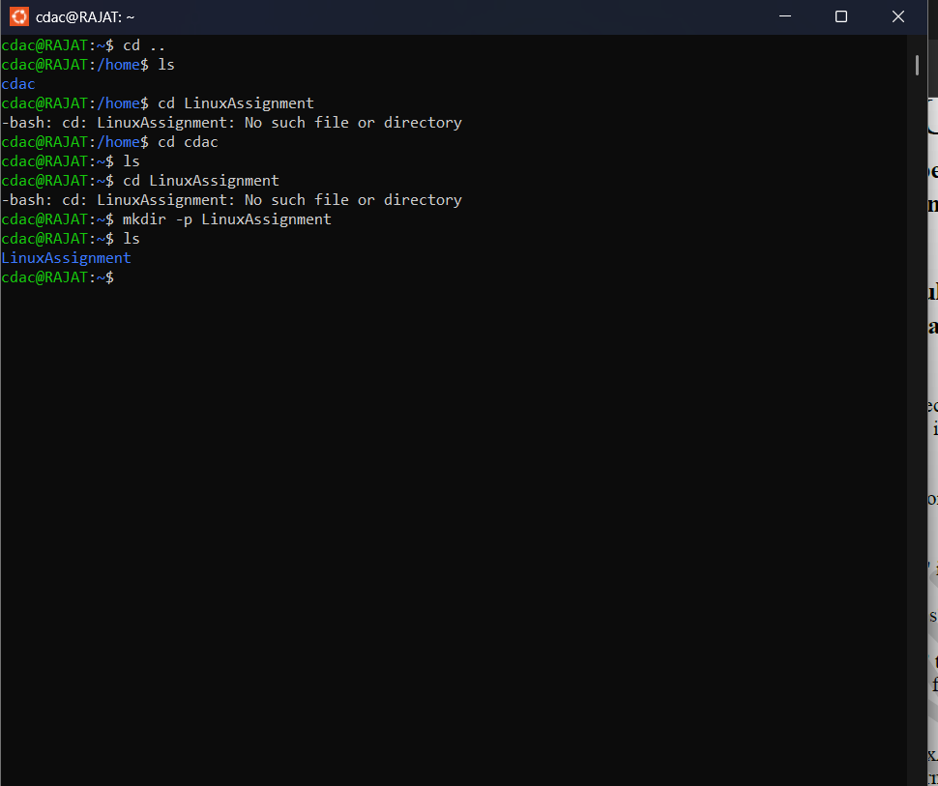

(b) File Management :

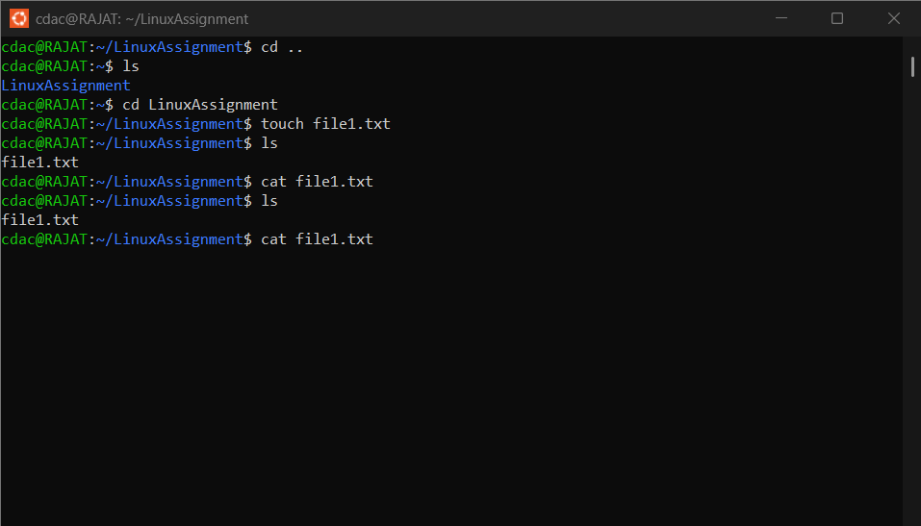

(c) Directory Management :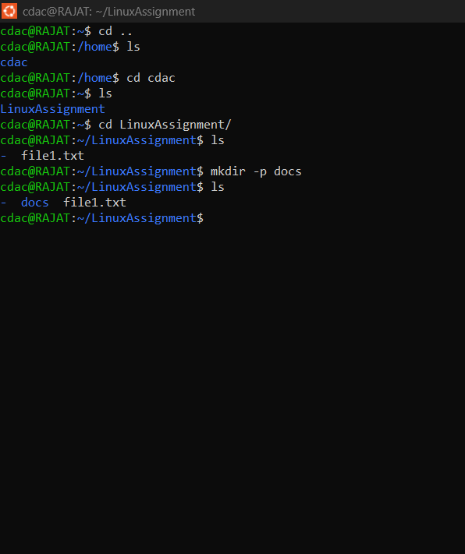

(d) Copy and Movie Files :

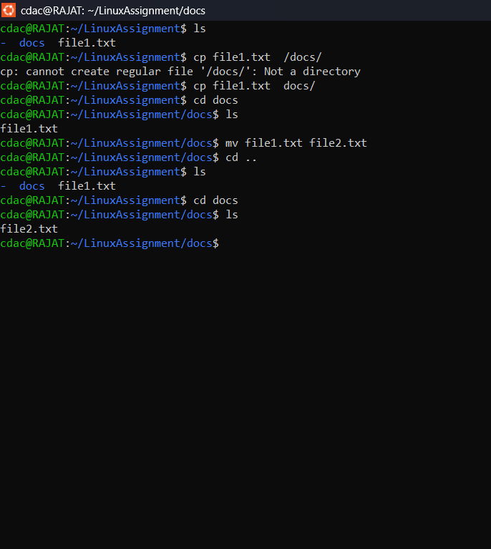

(e) Permission and Ownership:

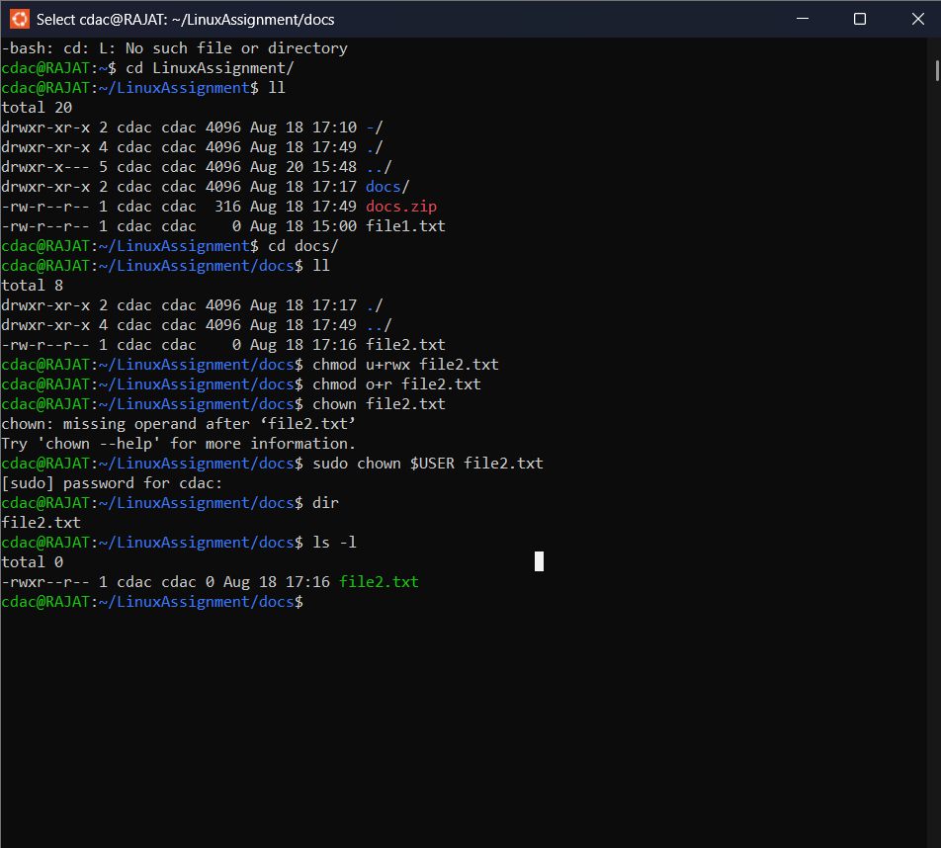

(f)Final Checklist :



(h) System date and time :

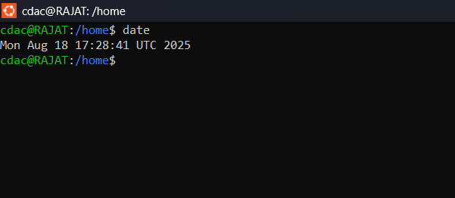

--------------------------------------------------------------------------------------------------------------------------------------

(i)Networking (a): Ipaddress of the system :

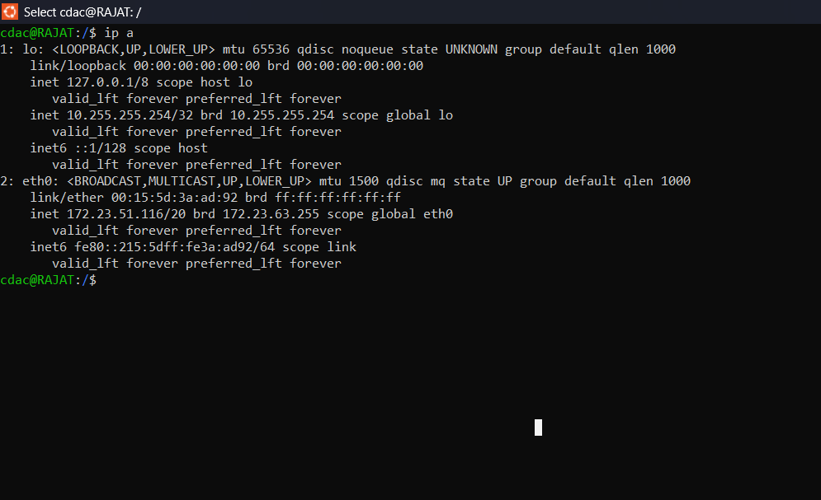

(i)Networking (b): ping remote server :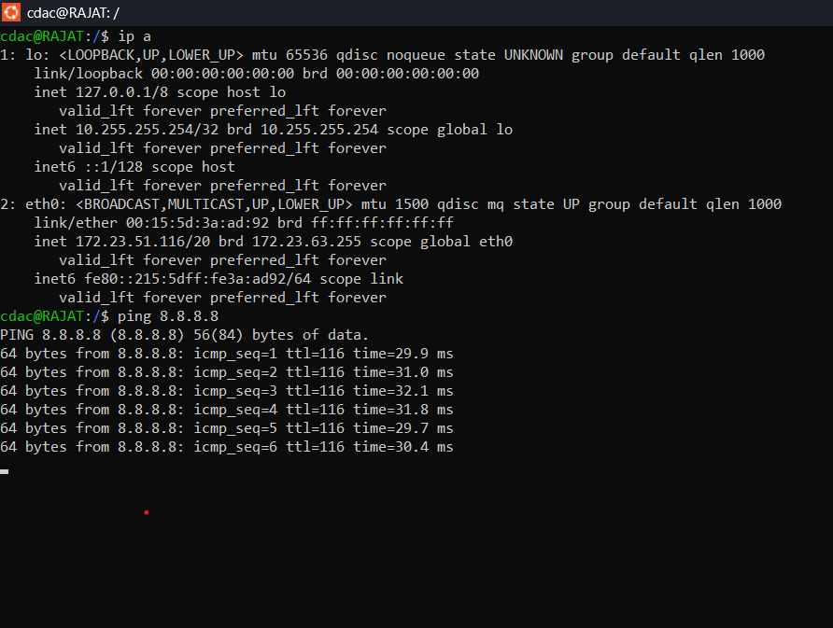

(j) File Compression:

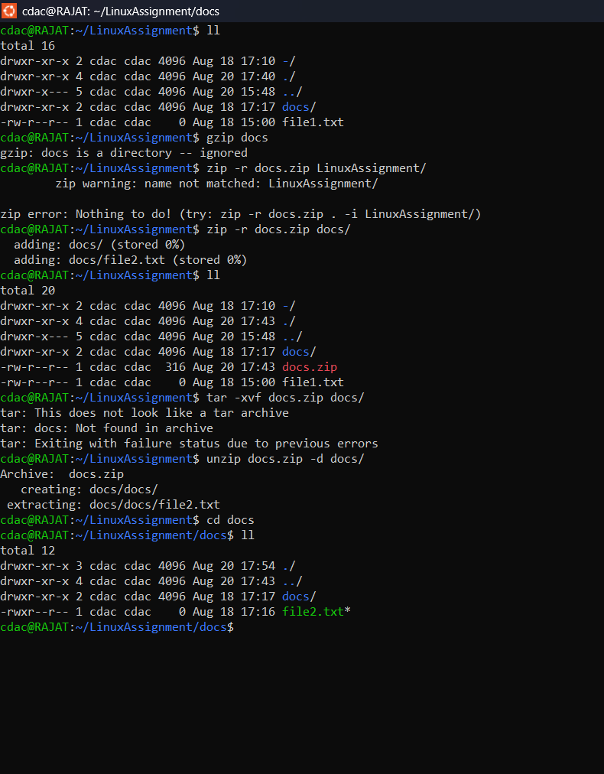

(k)File Editing : (a)

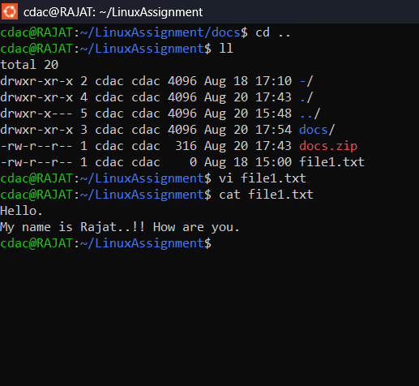

(k)File compression: (b)

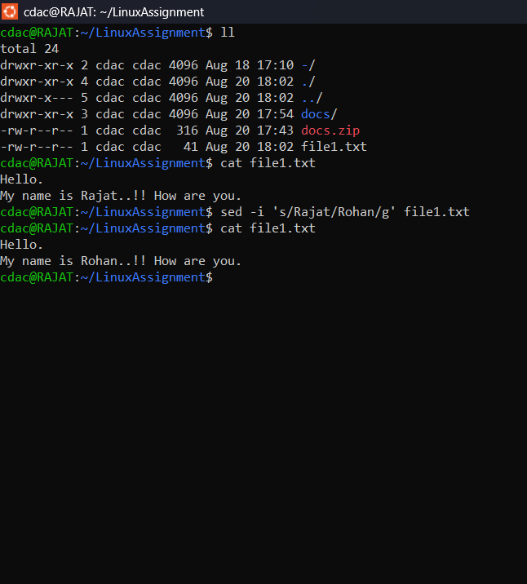

1. First 10 lines of command :

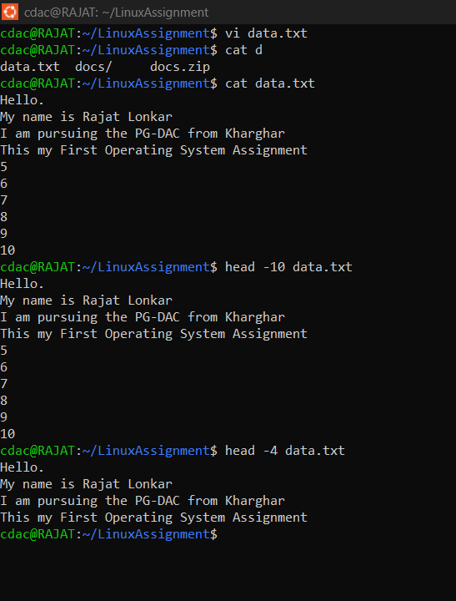

1. Last 5 lines of the data.txt :

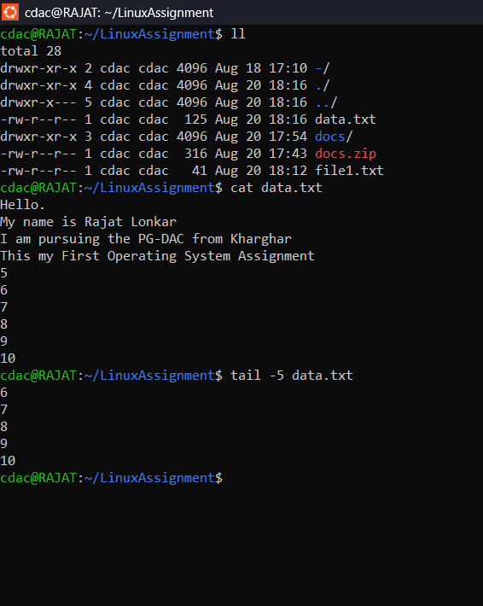

1. Numbers.txt display first 15 lines :

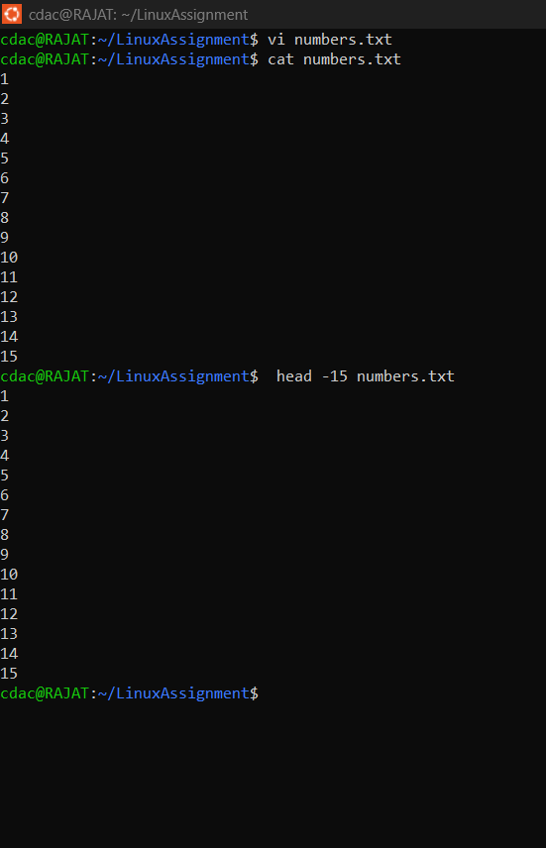

1. Last 3 lines of data.txt :

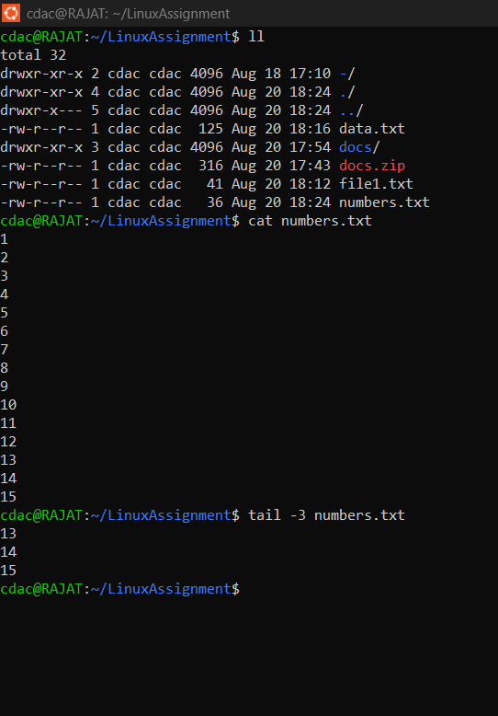

1. Copy from input.txt to output.txt :

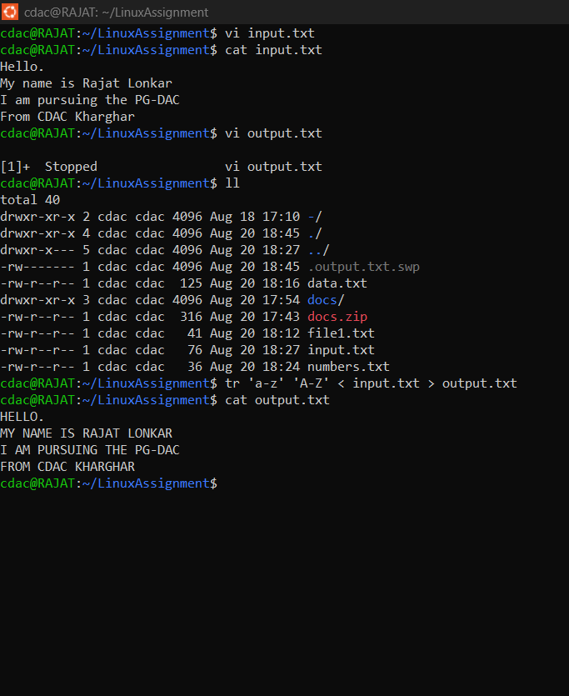

1. Uniqu display once :

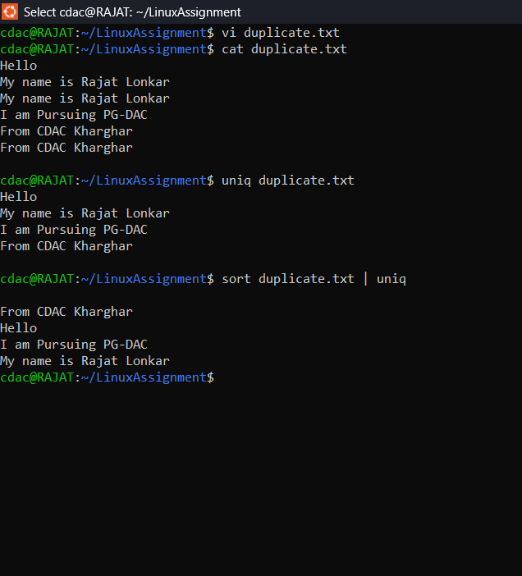

(g) Unique display with there count :

